**1. (a)Server Side Program**

PROGRAM:

import java.net.*;

import java.io.*;

class MyServer{

public static void main(String args[])throws Exception{

ServerSocket ss=new ServerSocket(3333);

Socket s=ss.accept();

DataInputStream din=new DataInputStream(s.getInputStream());

DataOutputStream dout=new DataOutputStream(s.getOutputStream());

BufferedReader br=new BufferedReader(new InputStreamReader(System.in));

String str="",str2="";

while(!str.equals("stop")){

str=din.readUTF();

System.out.println("client says: "+str);

str2=br.readLine();

dout.writeUTF(str2);

dout.flush();

}

din.close();

s.close();

ss.close();

}}

**1. (b)Client Side Program**

PROGRAM:

import java.net.*;

import java.io.*;

class MyClient{

public static void main(String args[])throws Exception{

Socket s=new Socket("localhost",3333);

DataInputStream din=new DataInputStream(s.getInputStream());

DataOutputStream dout=new DataOutputStream(s.getOutputStream());

BufferedReader br=new BufferedReader(new InputStreamReader(System.in));

String str="",str2="";

while(!str.equals("stop")){

str=br.readLine();

dout.writeUTF(str);

dout.flush();

str2=din.readUTF();

System.out.println("Server says: "+str2);

}

dout.close();

s.close();

}}

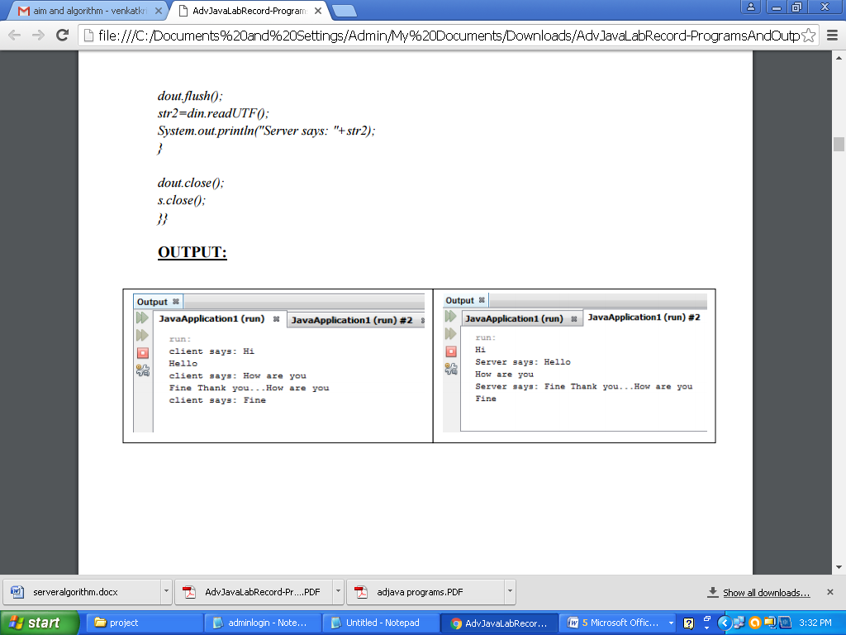

**2. DataBaseApp.java**

PROGRAM:

import java.sql.*;

class DataBaseApp

{

public static void main(String args[])

{

try

{

Class.forName("oracle.jdbc.driver.OracleDriver"); //step1 load the driver class

Connection

con=DriverManager.getConnection("jdbc:oracle:thin:@localhost:1521:xe", "system",

"manager"); //step2 create the connection object

Statement stmt=con.createStatement(); //step3 create the statement object

System.out.println("The Records from Emp Table Before Operations:.....");

ResultSet rs=stmt.executeQuery("select * from Emp"); //step4 execute query

while(rs.next())

{

System.out.println(rs.getInt(1)+" "+rs.getString(2)+" "+rs.getInt(3));

}

PreparedStatement pstmt=con.prepareStatement("insert into Emp values(?,?,?)");

pstmt.setInt(1,1006);//1 specifies the first parameter in the query

pstmt.setString(2,"Jadeja");

pstmt.setDouble(3,35000);

int i = pstmt.executeUpdate();

System.out.println("\n" + i + " Record(s) Inserted");

System.out.println("hai");

pstmt=con.prepareStatement("update Emp set ename=? where eno=?");

pstmt.setString(1,"Kohli");//1 specifies the first parameter in the query i.e. name

pstmt.setInt(2,1003);

i=pstmt.executeUpdate();

System.out.println("\n" + i +" Record(s) Updated");

pstmt=con.prepareStatement("delete from emp where eno=?");

pstmt.setInt(1,1004);

i=pstmt.executeUpdate();

System.out.println(i+" records deleted");

System.out.println("The Records from Emp Table After Operations:.....");

rs=stmt.executeQuery("select * from Emp"); //step4 execute query

while(rs.next())

{

System.out.println(rs.getInt(1)+" "+rs.getString(2)+" "+rs.getInt(3));

}

con.close(); //step5 close the connection object

}catch(Exception e){ System.out.println(e);}

}

}

**OUTPUT:**

The Records from Emp Table Before Operations...

1001 Raju 7000

1002 Ravi 20000

1003 Virat 30000

1004 Rina 35000

1005 Rahul 35000

1 Record(s) Inserted

1 Record(s) Updated

1 Record is Deleted

The Records from Emp Table After Operations...

1001 Raju 7000

1002 Ravi 20000

1003 Kohli 30000

1005 Rahul 35000

1006 Jadeja 35000

**3. PROGRAM:**

**3(a).Defining the RMI Interface */**

package rmiinterface;

import java.rmi.*;

public interface RMIinterface extends Remote{

public int add(int x,int y)throws RemoteException;

}

**3(b).The implementation of the RMI Interface */**

package rmiimplementation;

import java.rmi.RemoteException;

import java.rmi.server.UnicastRemoteObject;

import rmiinterface.RMIinterface;

public class RMIimplementation extends UnicastRemoteObject implements RMIinterface

{

public RMIimplementation()throws RemoteException

{

super();

}

public int add(int x,int y){return x+y;}

}

**3©.Create and Start the Remote Server Application */**

package myserver;

import java.rmi.*;

import java.rmi.registry.*;

import rmiimplementation.RMIimplementation;

import rmiinterface.RMIinterface;

public class MyServer {

public static void main(String[] args)

{

try{

RMIimplementation stub = new RMIimplementation();

Registry reg = LocateRegistry.createRegistry(5002);

reg.rebind("myserver", stub);

System.out.println("Server is Ready..");

}catch(Exception e){System.out.println(e);}

}

}

**3(d).Create and Execute the Client Application */**

package myclient;

import java.rmi.registry.LocateRegistry;

import java.rmi.registry.Registry;

import rmiinterface.RMIinterface;

import java.io.*;

import java.util.*;

public class MyClient {

public static void main(String[] args) {

try{

Registry myreg = LocateRegistry.getRegistry("localhost",5002);

RMIinterface stub=(RMIinterface)myreg.lookup("myserver");

DataInputStream din = new DataInputStream(System.in);

Scanner sc = new Scanner (System.in);

System.out.println("Enter First Number:");

int x = sc.nextInt();

System.out.println("Enter Second Number:");

int y = sc.nextInt();

System.out.println(stub.add(x,y));

}catch(Exception e){}

}

}

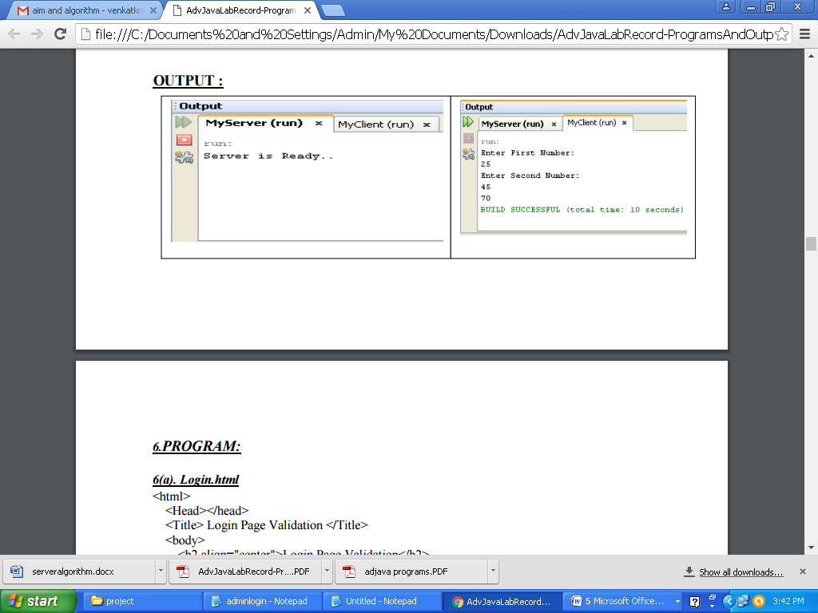

**4.servlet using cookies:**

4(a) IndexPage2.html

<html>

<Head>

<Title> Login Page Validation </Title>

</head>

<body>

<h2 align="center">Login Page Validation</h2>

<form method="get" action="Validation">

<table><tr>

<td>Enter Name:</td><td><input type="text" name="userName"/><td>

<td > <input type="submit" value="go"/> </td></tr></table>

</form>

</body>

</html>

**4(b) File: CookieServlet1.Java**

import java.io.*;

import javax.servlet.*;

import javax.servlet.http.*;

public class CookieServlet1 extends HttpServlet {

public void doPost(HttpServletRequest request, HttpServletResponse response){

try{

response.setContentType("text/html");

PrintWriter out = response.getWriter();

String n=request.getParameter("userName");

Out.println(“<br> ServletCookies1 Page…………….”);

out.print("Welcome To…… "+n);

Cookie ck=new Cookie("uname",n);//creating cookie object

response.addCookie(ck);//adding cookie in the response

//creating submit button

out.print("<form action='CookieServlet2'>");

out.print("<input type='submit' value='go'>");

out.print("</form>");

out.close();

}catch(Exception e){System.out.println(e);}

}

}

**4(c) File : CookieServlet2.Java**

import java.io.*;

import javax.servlet.*;

import javax.servlet.http.*;

public class CookieServlet2 extends HttpServlet {

public void doPost(HttpServletRequest request, HttpServletResponse response){

try{

response.setContentType("text/html");

PrintWriter out = response.getWriter();

Cookie ck[]=request.getCookies();

out.println(“<br> Cookies Servlet2 Page”);

out.print("<br>Hello…. "+ck[0].getValue());

out.close();

}catch(Exception e){System.out.println(e);}

}

}

**4(d)web.xml**

<web-app>

<servlet>

<servlet-name>s1</servlet-name>

<servlet-class>CookieServlet1</servlet-class>

</servlet>

<servlet-mapping>

<servlet-name>s1</servlet-name>

<url-pattern>/CookieServlet1</url-pattern>

</servlet-mapping>

<servlet>

<servlet-name>s2</servlet-name>

<servlet-class>CookieServlet2</servlet-class>

</servlet>

<servlet-mapping>

<servlet-name>s2</servlet-name>

<url-pattern>/CookieServlet2</url-pattern>

</servlet-mapping>

</web-app>

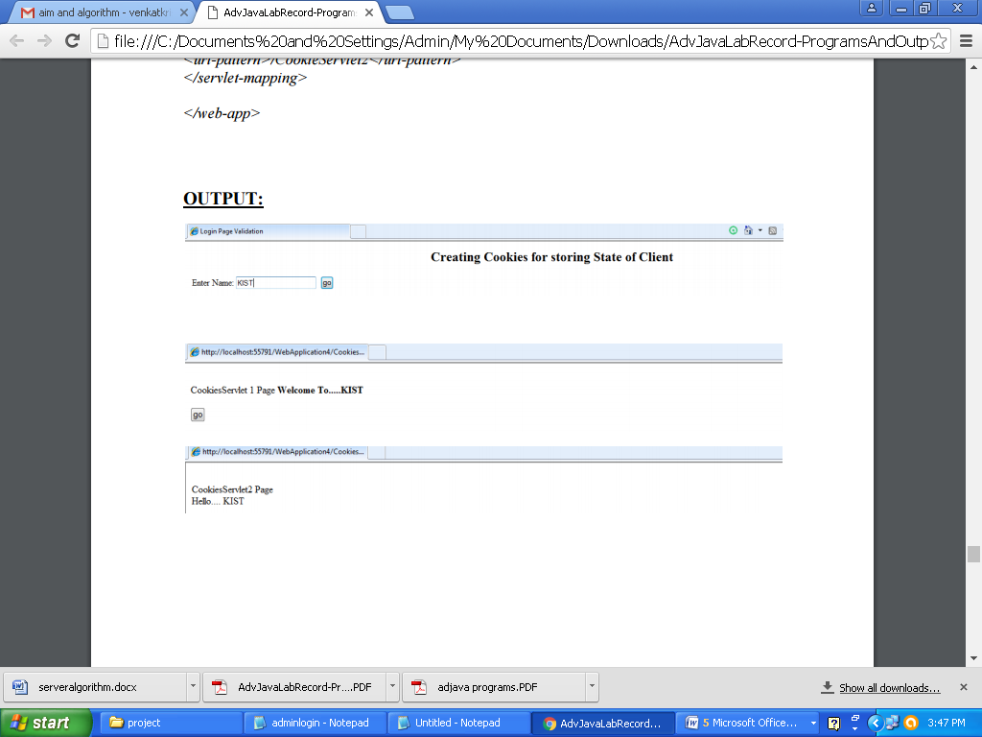

**5. creating a simple servlet:**

(A) generic servlet

<!DOCTYPE html>

<html>

<head>

<meta charset="UTF-8">

<title>Generic Servlet Demo</title>

</head>

<body>

<a href="welcome">Click to call Servlet</a>

</body>

</html>

**5(b) servlet program**

import java.io.*;

import javax.servlet.*;

public class ExampleGeneric extends GenericServlet{

public void service(ServletRequest req,ServletResponse res)

throws IOException,ServletException{

res.setContentType("text/html");

PrintWriter pwriter=res.getWriter();

pwriter.print("<html>");

pwriter.print("<body>");

pwriter.print("<h2>Generic Servlet Example</h2>");

pwriter.print("<p>Hello BeginnersBook Readers!</p>");

pwriter.print("</body>");

pwriter.print("</html>");

}

}

**5(c) web.xml program**

<web-app>

<display-name>BeginnersBookServlet</display-name>

<welcome-file-list>

<welcome-file>index.html</welcome-file>

<welcome-file>index.htm</welcome-file>

<welcome-file>index.jsp</welcome-file>

<welcome-file>default.html</welcome-file>

<welcome-file>default.htm</welcome-file>

<welcome-file>default.jsp</welcome-file>

</welcome-file-list>

<servlet>

<servlet-name>MyGenericServlet</servlet-name>

<servlet-class>ExampleGeneric</servlet-class>

</servlet>

<servlet-mapping>

<servlet-name>MyGenericServlet</servlet-name>

<url-pattern>/welcome</url-pattern>

</servlet-mapping>

</web-app>

**OUTPUT**

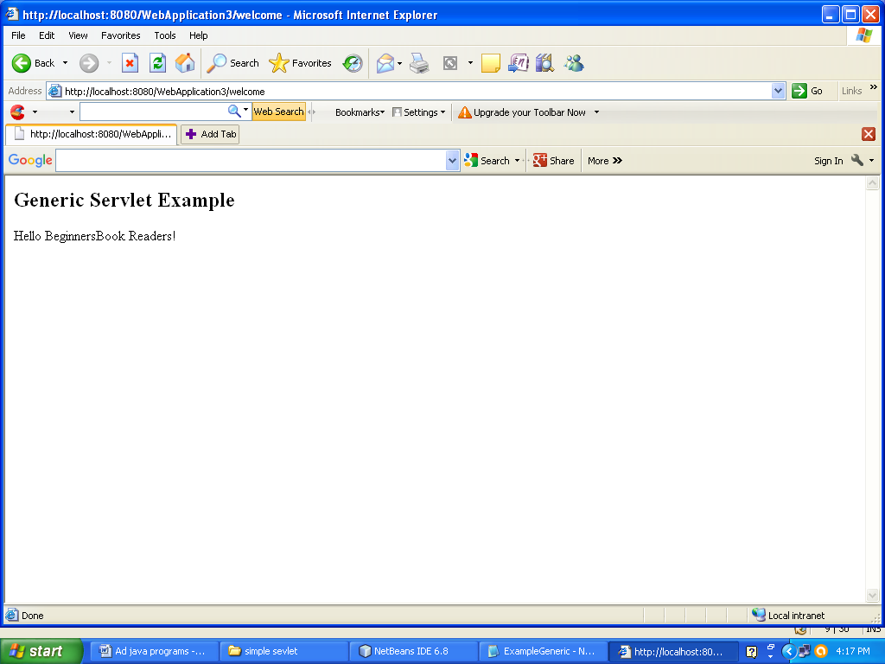

**6. Socket program:**

package sssocket;

import java.io.*;

import java.net.*;

public class MyServer {

public static void main(String[] args){

try{

ServerSocket ss=new ServerSocket(2419);

Socket s=ss.accept();//establishes connection

DataInputStream dis=new DataInputStream(s.getInputStream());

String str=(String)dis.readUTF();

System.out.println("message= "+str);

ss.close();

}catch(Exception e){System.out.println(e);}

}

}

**Client program:**

package sssocket;

import java.io.*;

import java.net.*;

public class MyClient {

public static void main(String[] args) {

try{

Socket s=new Socket("localhost",2419);

DataOutputStream dout=new DataOutputStream(s.getOutputStream());

dout.writeUTF("Hello Server");

dout.flush();

dout.close();A

s.close();

}catch(Exception e){System.out.println(e);}

}

}

**OUTPUT**

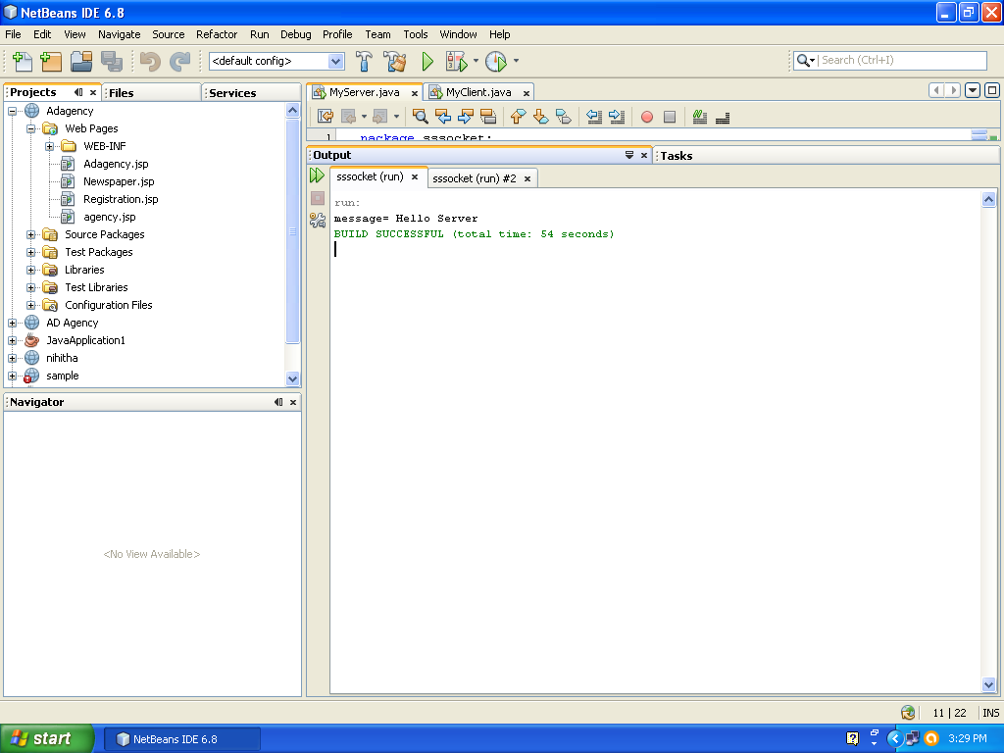

**7. Jdbc program for selecting all data from database**

<%@page contentType="text/html" pageEncoding="UTF-8"%>

<!DOCTYPE HTML PUBLIC "-//W3C//DTD HTML 4.01 Transitional//EN"

"http://www.w3.org/TR/html4/loose.dtd">

<%@ page import="java.sql.*" %>

<%@ page import="java.io.*" %>

<HTML>

<HEAD>

<TITLE>insert data using prepared statement </TITLE>

</HEAD>

<BODY bgcolor="#ffffcc">

<font size="+3" color="green"><br>Welcome in www.roseindia.net !</font>

<FORM action="query.jsp">

<TABLE style="background-color: #ECE5B6;" WIDTH="30%" >

<TR>

<TH width="50%">Name</TH>

<TD width="50%"><INPUT TYPE="text" NAME="name"></TD>

</TR>

<TR>

<TH width="50%">City</TH>

<TD width="50%"><INPUT TYPE="text" NAME="city"></TD>

</TR>

<TR>

<TH width="50%">Phone</TH>

<TD width="50%"><INPUT TYPE="text" NAME="phone"></TD>

</TR>

<TR>

<TH></TH>

<TD width="50%"><INPUT TYPE="submit" VALUE="submit"></TD>

</TR>

</TABLE>

<%

String name = request.getParameter("name");

String city = request.getParameter("city");

String phone = request.getParameter("phone");

/* Create string of connection url within specified

format with machine name,

port number and database name. Here machine name id

localhost and database name is student. */

String connectionURL = "jdbc:oracle:thin:@localhost:1521:XE";

// declare a connection by using Connection interface

Connection connection = null;

// declare object of Statement interface that uses for

//executing sql statements.

PreparedStatement pstatement = null;

// Load JBBC driver "com.mysql.jdbc.Driver"

Class.forName("oracle.jdbc.driver.OracleDriver").newInstance();

int updateQuery = 0;

// check if the text box is empty

if(name!=null && city!=null && phone!=null){

// check if the text box having only blank spaces

if(name!="" && city!="" && phone!="") {

try {

/* Create a connection by using getConnection()

method that takes parameters of string type

connection url, user name and password to connect

to database. */

connection = DriverManager.getConnection

(connectionURL, "system", "manager");

// sql query to insert values in the secified table.

String queryString = "INSERT INTO stu_info(Name,Address,Phone) VALUES (?, ?, ?)";

/* createStatement() is used for create statement

object that is used for

sending sql statements to the specified database. */

pstatement = connection.prepareStatement(queryString);

pstatement.setString(1, name);

pstatement.setString(2, city);

pstatement.setString(3, phone);

updateQuery = pstatement.executeUpdate();

if (updateQuery != 0) { %>

<br>

<TABLE style="background-color: #E3E4FA;"WIDTH="30%" border="1">

<tr><th>Data is inserted successfully

in database.</th></tr>

</TABLE>

<%

}

}

catch (Exception ex) {

out.println("Unable to connect to batabase.");

}

finally {

// close all the connections.

pstatement.close();

connection.close();

} }

}

%>

</FORM>

</body>

</html>

**OUTPUT**

